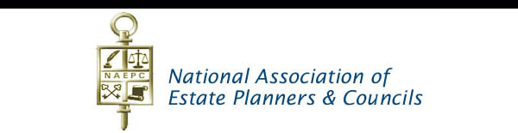

**Estate Planning Council of the Emerald Coast, Inc.**

**2024 MEMBERSHIP APPLICATION  
Dues $250.00**

All members must be actively practicing in the family wealth or

Estate planning field and be current in their annual dues.

**Name:_____________________________________ Company:________________________________________**

**Address:**

**City: State: Zip:**

**Phone: Fax: Email:**

**Sponsoring member** *(new applicants)***: _______________________________________________________**

Please select one of the following categories of which you will be categorized:

□Accountant □Fundraising Exec. Director □Other __________________

□Attorney □Insurance Professional

□Care Management □Investment Advisor

□Financial Planner □Trust Officer

**BENEFITS OF MEMBERSHIP**

* Outstanding networking with members of multiple disciplines at every meeting
* A Variety of Speakers, Topics, and Educational Opportunities
* Attendance at our bi-monthly Dinner Meetings, and upscale Annual Meeting Dinner included
* Attendance Fee to EPC of Gulf Coast Annual Conference in Mobile, AL in September included
* Opportunity to advertise and submit an article for the November Estate Planning Supplement in NWFL Daily News
* Your name and contact information in the EPCEC directory in NWFL Daily News Supplement
* Your name and contact information in a EPCEC advertisement to be placed in the NWFL Daily News
* Your name and company name on our online directory at [www.emeraldcoastestate.org](http://www.emeraldcoastestate.org)
* Opportunity to participate in EPCEC Estate Planning Awareness Day activities
* Access to a wide array of NAEPC Resources

**2024 Dues Payment Information**

Amount enclosed: $_________

Please select one of the following forms of payment: Check Cash________________

# Mail, fax or email your membership form with payment to: Estate Planning Council of the Emerald Coast

# P.O. Box 784, Destin, Florida 32540

**Email: denise.harris1313@gmail.com**